TITLE

Project Report

SUPERVISOR: Supervisor Name

SUBMITTED BY

Name1 Exam Roll Number1

Name2 Exam Roll Number2



2022

Department of Computer Science

ACHARYA NARENDRA DEV COLLEGE

ACKNOWLEDGEMENT

**General Instructions for the report**

1. Running Text should be in 12 pt Times New Roman Justified on both sides.
2. Captions of tables should be on top of table while of figures, captions should be below figures. Keep caption of tables/figures in 10 Pt. Times New Roman.
3. There should not be any free space left after tables or figures at the bottom of the page. Adjust your text, figures and tables such that it should look a continuous document.
4. Chapter Title : Times New Roman 16 Pt Bold center Aligned
5. Head1 Title:... Times New Roman 14 Pt. Bold
6. Head2 Title….Times New Roman 12 Pt. Bold
7. Margins…Normal: 1 inch from top, bottom, left, right
8. Inter line spacing: 1.15............. ..................... .................

............. ................. .................. ............ ................... ........................

.................... .................



name 1 name 2 name 3

**ACHARYA NARENDRA DEV COLLEGE**

**(University of Delhi**)

**CERTIFICATE**

Certificate text. . . . .. . . . . . .. . . . . .. . . . . .. . . . . . . . . .. . . .

. . .. . . . . .. . . . . .. . . . . . . . . .. . . . . . .. . . . . .. . . . . .. . . . . . .

. . .. . . . . . .. . . . . .. . . . . .. . . . . . . . . .. . . . . . .. . . . . .. . . . .

.. . . . . . . . . .. . . . . . .. . . . . .. . . . . .. . . . . . . . . .. . . . . . .. . . .

. .. . . . . .. . . . . . . . . .. . . . . . .. . . . . .. . . . . .. . . . . . . . . .. . . .

. . .. . . . . .. . . . . .. . . . . . . . . .. . . . . . .. . . . . .. . . . . .. . . . . . .

. . .. . . . . . .. . . . . .. . . . . .. . . . . . . . . .. . . . . . .. . . . . .. . . . .

.. . . . . . . . . .. . . . . . .. . . . . .. . . . . .. . . . . . . . . .. . . . . . .. . . .

. .. . . . . .. . . . . . . . . .. . . . . . .. . . . . .. . . . . .. . . . . . . . . .. . . .

. . .. . . . . .. . . . . .. . . . .



name 1 name 2 name 3



Supervisor

Supervisor name

**Contents**

1 PROBLEM STATEMENT

2 PROCESS MODEL

3 REQUIREMENT ANALYSIS & MODELING

3.1 DFD . . . . . . . . . . . . . . . . . . . . . . . . . . . . . . . .

3.1.1 Context Level DFD . . . . . . . . . . . . . . . . . . . .

3.1.2 Level 1 DFD . . . . . . . . . . . . . . . . . . . . . . .

3.1.3 Level 2 DFD . . . . . . . . . . . . . . . . . . . . . .

3.2 Data Dictionary . . . . . . . . . . . . . . . . . . . . . . . . . .

3.3 Use Case Diagram

3.4 Sequence Diagram

4 SOFTWARE REQUIREMENT SPECIFICATION (SRS)

4.1 Overall Description . . . . . . . . . . . . . . . . . . . . . . . .

4.1.1 Product Functions . . . . . . . . . . . . . . . . . . . .

4.1.2 User Characteristics . . . . . . . . . . . . . . . . . . . .

4.1.3 General Constraints . . . . . . . . . . . . . . . . . . . .

4.1.4 Assumptions and Dependencies . . . . . . . . . . . . .

4.2 External Interface Requirements . . . . . . . . . . . . . . . . .

4.2.1 User Interface . . . . . . . . . . . . . . . . . . . . . . .

4.2.2 Hardware Interface . . . . . . . . . . . . . . . . . . . .

4.2.3 Software Interface . . . . . . . . . . . . . . . . . . . . .

4.3 Functional requirements . . . . . . . . . . . . . . . . . . . . .

4.3.1 FR1 Login Requirement . . . . . . . . . . . . . . . . .

4.3.2 FR2 Registration Form Requirement . . . . . . . . . .

4.3.3 FRn XXX Requirement . . . . . . . . . . . . . . . . .

4.4 Performance Requirements . . . . . . . . . . . . . . . . . . . .

4.4.1 Performance Requirement 1 . . . . . . . . . . . . . . .

4.4.2 Performance Requirement 2 . . . . . . . . . . . . . . .

4.4.3 Performance Requirement 3 . . . . . . . . . . . . . . .

4.5 Design Constraints . . . . . . . . . . . . . . . . . . . . . . . .

5 ESTIMATIONS

5.1 Function Points . . . . . . . . . . . . . . . . . . . . . . . . . .

5.2 Effort . . . . . . . . . . . . . . . . . . . . . . . . . . . . . . .

5.3 Cost . . . . . . . . . . . . . . . . . . . . . . . . . . . . . . .

6 SCHEDULING

6.1 Timeline Chart

7 RISK MANAGEMENT

7.1 Risk Table

8 DESIGN

8.1 Structural Chart . . . . . . . . . . . . . . . . . . . . . . . . . …

8.2 Pseudo Code . . . . . . . . . . . . . . . . . . . . . . . . . …

9 CODING

9.1 Code Snippet 1 (write module name) . . . . . . . . . . . . . .

9.2 Code Snippet 2 (write module name) . . . . . . . . . . . . . .

10 TESTING

10.1 Test Case Design . . . . . . . . . . . . . . . . . . . . . . .

10.2 Flow Graph . . . . . . . . . . . . . . . . . . . . . . . .

10.3 Basis Path Set . . . . . . . . . . . . . . . . . . . . . . . . . . .

10.4 Cyclomatic Complexity . . . . . . . . . . . . . . . . . . . . . .

11 References

**Chapter 1**

**PROBLEM STATEMENT**

Statement

**Chapter 2**

**PROCESS MODEL**

What process model you are using (describe with diagram) Explain why you are using.

**Chapter 3**

**Requirement Analysis & Modeling**

**3.1 DFD**

Give definition of DFD.

**3.1.1 Context Level DFD**

Give definition and then give for your project.



Figure 3.1: Context Level DFD

**3.2.2 Level 1 DFD**

Give Defn and then present DFD for your project.

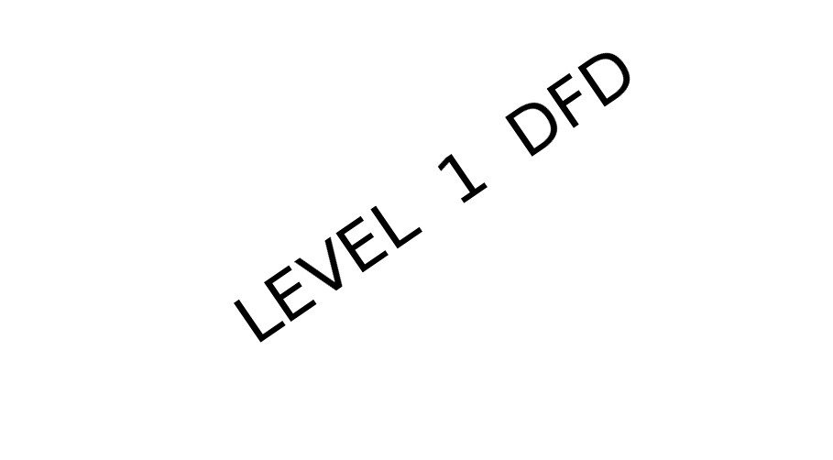

Figure 3.2: Level 1 DFD

**3.1.3 Level 2 DFD**

Give definition and present DFD of your project.



Figure 3.3: Level 2 DFD

**3.2 Data Dictionary**

Give definition of DD and then give DD for your project.

**3.3. Use Case Diagrams**

Give definition of use case and then give use cases for your project.

**3.4 Sequence Diagrams**

Give definition of Sequence Diagram and then give sequence diagram for your project.

**Chapter 4**

**SOFTWARE REQUIREMENT SPECIFICATION**

CONTENT

some text describing what is SRS

**4.1 Overall Description**

Purpose of this SRS (remove this example and write the purpose of your project)

Example: The purpose of the Software Requirements Specification document is to clearly define the system under development, namely the Video Rental System (VRS). The intended audience of this document includes the owner of the video store, the clerks of the video store, and the end users of the VRS. Other intended audience includes the development team such as the requirements team, requirements analyst, design team, and other members of the developing organization.

**4.1.1 Product Functions**

Remove in formal document (content - Defines the relationship this product has in the entire spectrum of products. It defines who will be responsible for the product and what business purpose it serves. It also defines what interfaces it may have to other systems. eg. The VRS is a web-based system. The system interfaces with two other systems, the owner’s email system, the video distributor’s

video system, and the browsers used by VRS customers. The sys- tem provides a secure environment for all financial transactions and for the storing and retrieving of confidential member information.

)

**4.1.2 User Characteristics**

Remove in formal document (content - List the users involved with the proposed system including the general characteristics of eventual users (for example, educational back- ground, amount of product training). List the responsibility of each type of user involved, if needed. eg. The three main groups of VRS users are customers, members, and store personnel. 1. A customer is anyone who is not a member. The customer can only search through the video inventory. The amount of product training needed for a customer is none since the level of technical expertise and educational back- ground is unknown. The only skill needed by a customer is the ability to browse a website. 2. Member is someone who has registered with VRS. A member can rent videos and pay fees online. As with a customer, these activities require no product training since the level of technical expertise and educational background of a member is unknown. The only skill needed by a member is the ability to browse a website. 3. The store personnel are divided into two groups: • Clerical personnel : Their educational level is un- known and both group needs little to no training. • Administrator personnel: Should be fully trained to use this sys- tem. )

**4.1.3 General Constraints**

Remove in formal document and write your own general constraints the constraints of the system are listed. They include hardware, network, system software, and software constraints. It also includes user constraints, processing constraints, timing constraints, and control limits. eg. This system provides web access for all customer and member functions. The user interface will be intuitive enough so that no training is required by customers, members, or store personnel. All online financial transactions and the storage of confidential member information will be done in a secure environment. Persistent storage for membership, rental, and video inventory information will be maintained.

**4.1.4 Assumptions and Dependencies**

Remove the below description and write your own A D This includes assumptions made at the beginning of the development effort as well as those made during the development. List and de- scribe each of the factors that affect the requirements stated in the SRS. These factors are not design constraints on the software but any changes to them can affect the requirements in the SRS. For example, an assumption might be that a specific operating sys- tem will be available on the hardware designated for the software product. If, in fact, the operating system is not available, the SRS would then have to change. eg. It is assumed that video and existing member data will be made available for the project in some phase of its completion. Until the, test data will be used for pro- viding the demo for the presentations. It is assumed that the user is familiar with an internet browser and also familiar with handling the keyboard and mouse. Talk about the need of special platforms or specific OS. Eg it will work on Mozilla Firefox version or IE7. Work only on Android smartphones etc.

**4.2 External Interface Requirements**

The member has to register using a form provided on the website. The user can input data with the help of the keyboard or click with the mouse wherever necessary. The package provides pull down menus from which the user can select and links and icons to navigate among the web pages.

**4.2.1 User Interface**

Remove the below description and write your own UI. (Will the software require any external UI, if yes describe. Eg UI of this application is compatible with IE vesrion, chrome, mozzila etc. Any tools used to implement the UI like java apps, beans etc.)

**4.2.2 Hardware Interface**

Remove the below description and write your own HI. Does it need to connect to any external hardware, like some external simulator systems or system hardware like modem , LAN etc. eg • Clients Intel Pentium III 300 MHz or 1.0 GHz Athlon or faster • At least

256 MB RAM At least 200 MB freed hard disk space • At least

200 MB freed hard disk space

**4.2.3 Software Interface**

Remove the below description and write your own SI. Does it need some external software interaction like using an external database for querying or security systems for authentication or payment portals. Describe that eg. • Web: Internet Explorer or Netscape Navigator • J2EE Application Server The deploy tool from Sun will be used to maintain the EJB’s

**4.3 Functional requirements**

**4.3.1 FR1 Login Requirement**

**4.3.2 FR2 Registration Form Requirement**

**4.3.3 FRn XXX Requirement**

**4.4 Performance Requirements**

Skip if not applicable If applicable example:

**4.4.1 Performance Requirement 1**

The application should be portable and possible to users of Netscape Navigator as well as Internet Explorer.

**4.4.2 Performance Requirement 2**

**4.4.3 Performance Requirement 3**

**4.5 Design Constraints**

Remove this description and add design constraints of your project (if applicable, else skip this section) Design constraints are conditions that need to happen for a project to be successful. Design constraints help narrow choices when creating a project. eg. 1. Software Language: All coding will be done in standard C 2. The software can support a maximum of 500 members 3. It can support a maximum of 2000 videos.

**Chapter 5**

**Estimations**

**5.1 Function Points**

content Describe Function Points Why are they needed? and Compute FP

for this project

**5.2 Efforts**

content How to compute effort and Compute Effort for this project

**5.3 Cost**

Compute estimated cost for your project using COCOMO model.

**Chapter 6**

**Scheduling**

Content: Gantt Chart of the Project Schedule with definition.

**Chapter 7**

**Risk Management**

Define Risk Management in Brief .

**7.1 Risk Table**

Give definition of Risk Table and then give for your project.

**Chapter 8**

**DESIGN**

Design Description

**8.1 Structured Chart**

Definition of structured chart and then give SCs for your project.

Figure 8.1: Structured Chart

* 1. **Pseudo Code**

Write the pseudo code for various modules in your project.

**Chapter 9**

**CODING**

content: insert code snippets screenshots of major input and output flows

**9.1 Code Snippet 1 (write module name)**

code

**9.2 Code Snippet 2 (write module name)**

code

and so on

**Chapter 10**

**TESTING**

Content

White Box Testing describe

Black Box Testing describe

**10.1 Test Case Design**

insert table for test cases

**10.2 Flow Graph**

Give definition of flow graph and then insert flow graph of various modules.

**10.3 Basis Path Set**

Give definition of basis path set and then give the basis path set of the various modules

**10.4 Cyclomatic Complexity**

Give definition of cyclomatic complexity and compute cyclomatic complexity of various modules.

**Chapter 11**

**References**

**Bibliography**

23